Linux Fundamentals

================================================================

Submitted to Vikul_Sir

Submitted by Nalathati Rahul

Submission Date –03/Feb/2026

================================================================

L3 - In EC2 Ubuntu Instance Create Files and Directories and Grand R/W/X Access only to the Owner and User Group

Step: 1 Step:1 Go to AWS console and login with credentials

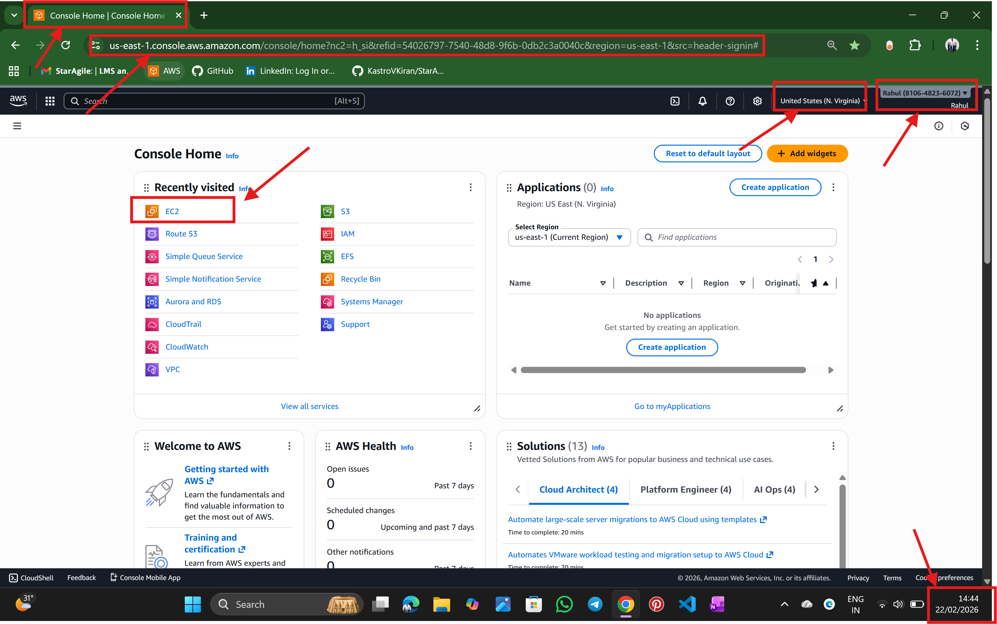

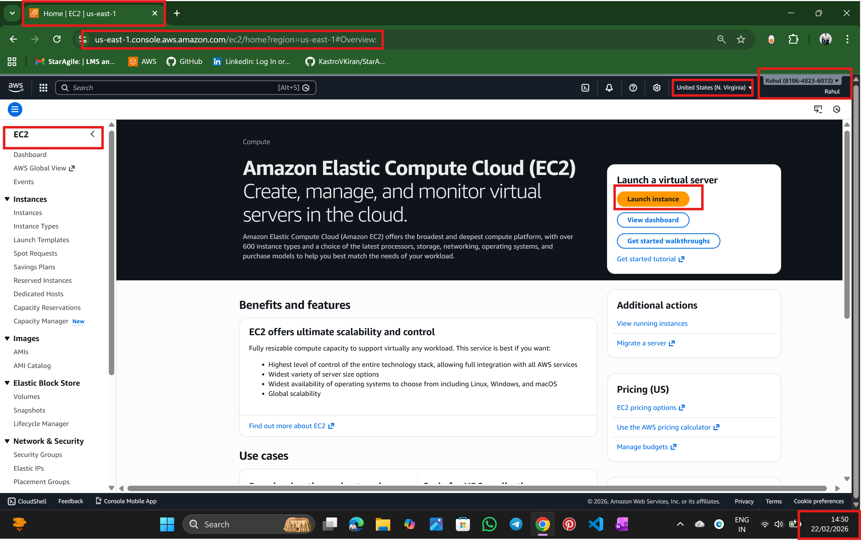

Step:2 Go to EC2 service

🡪select the name of the server

🡪select the AMI (Ubuntu)

🡪select the instance type

🡪select the key pair

🡪select the security group

And create instance by launch instance

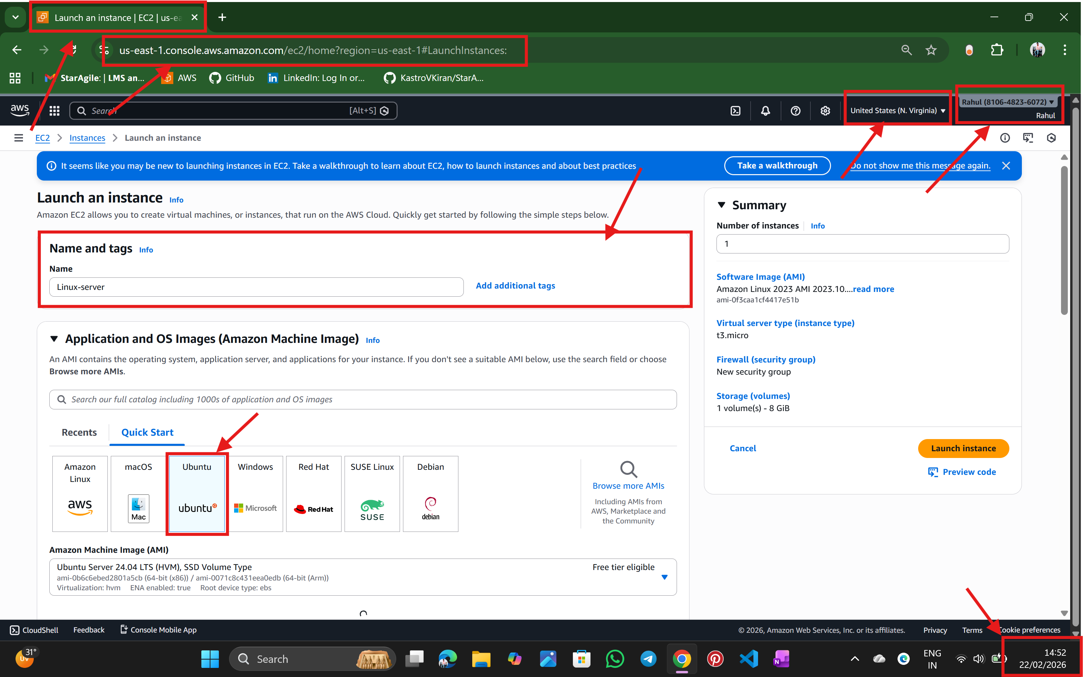

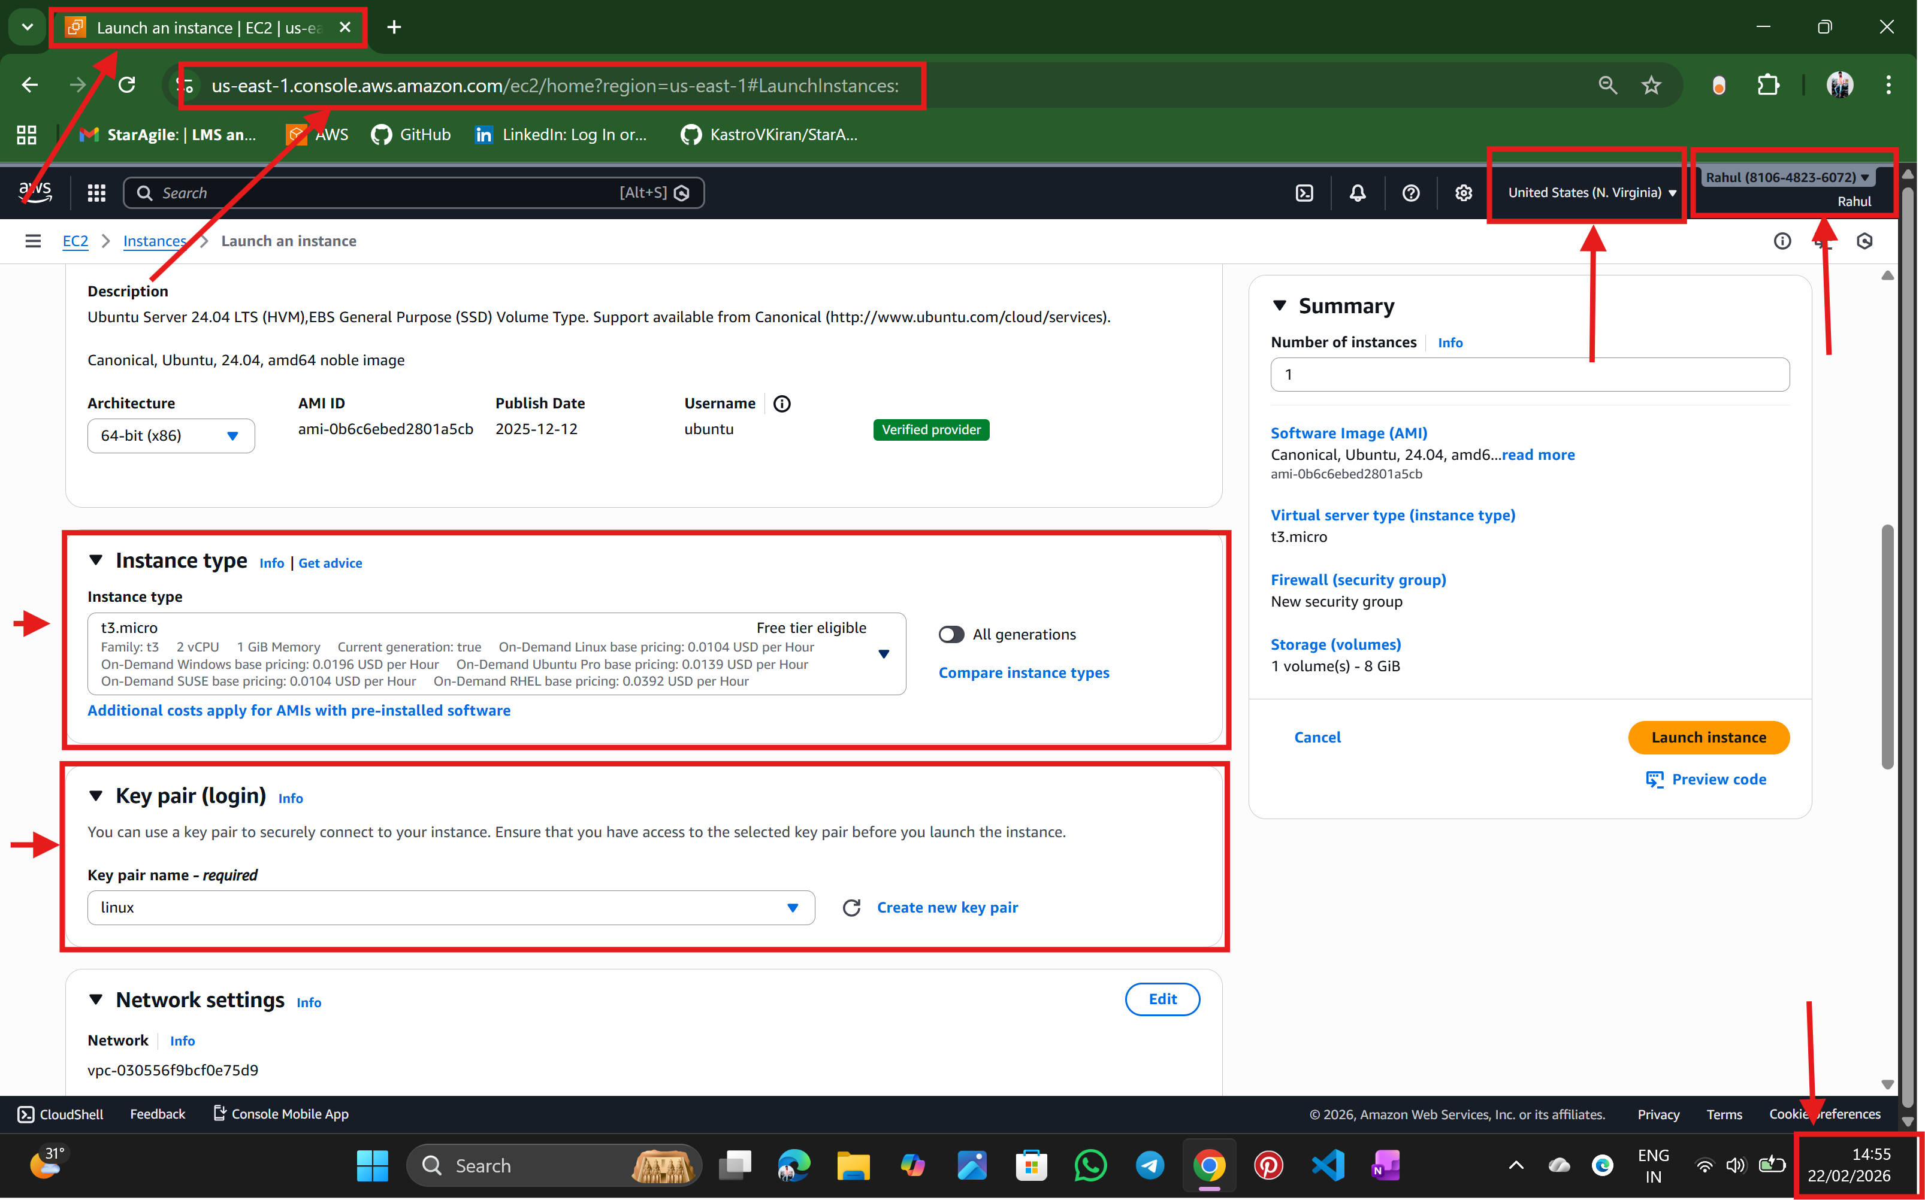

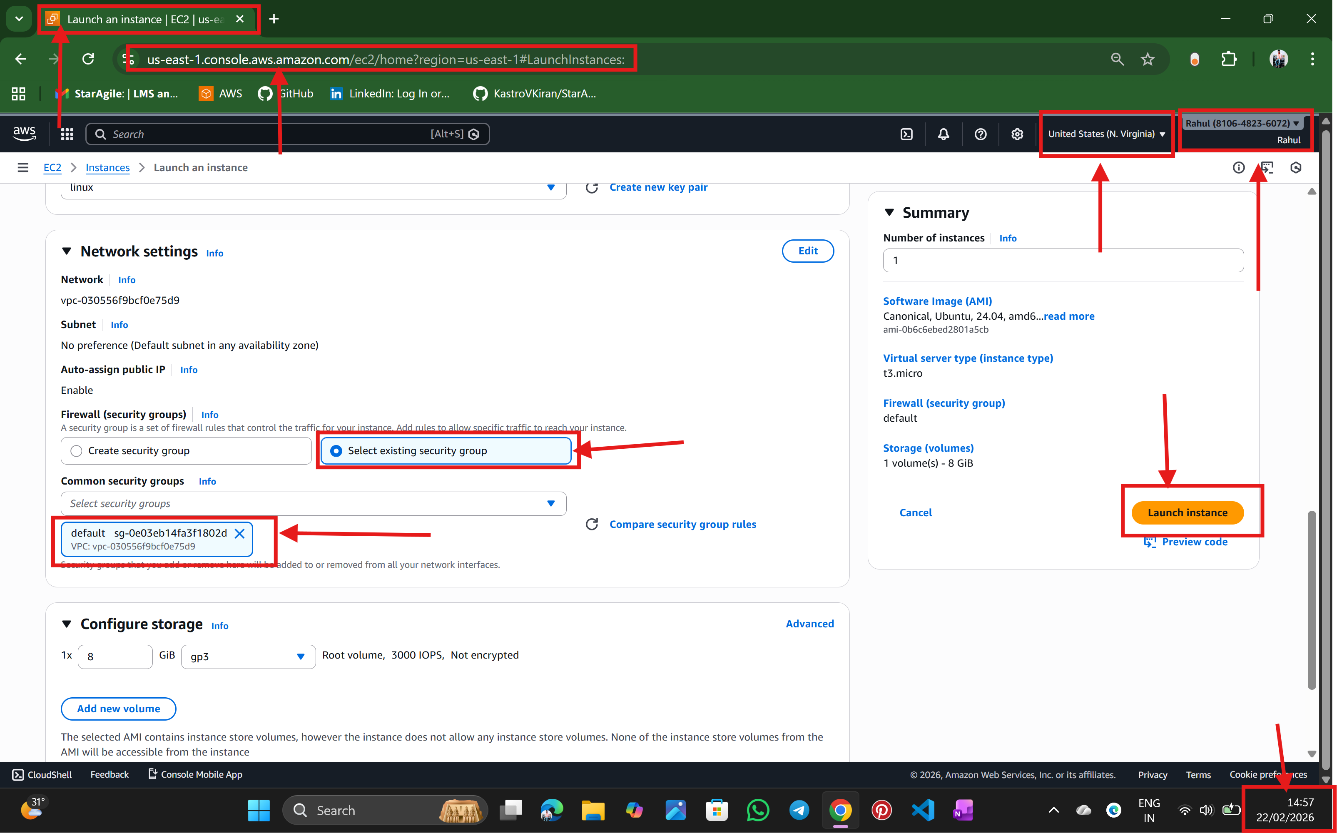

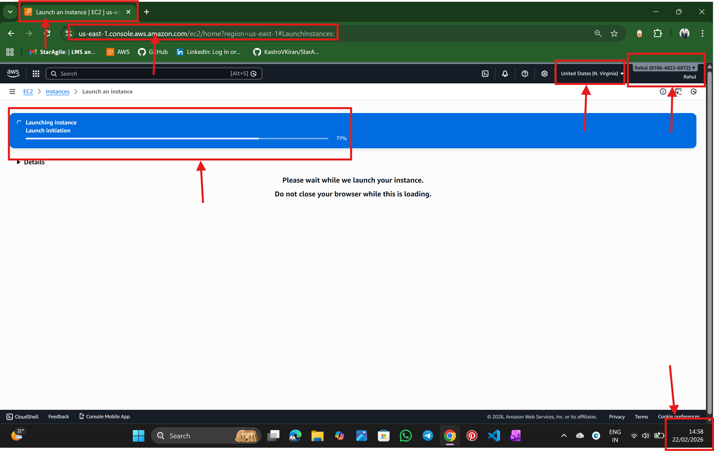

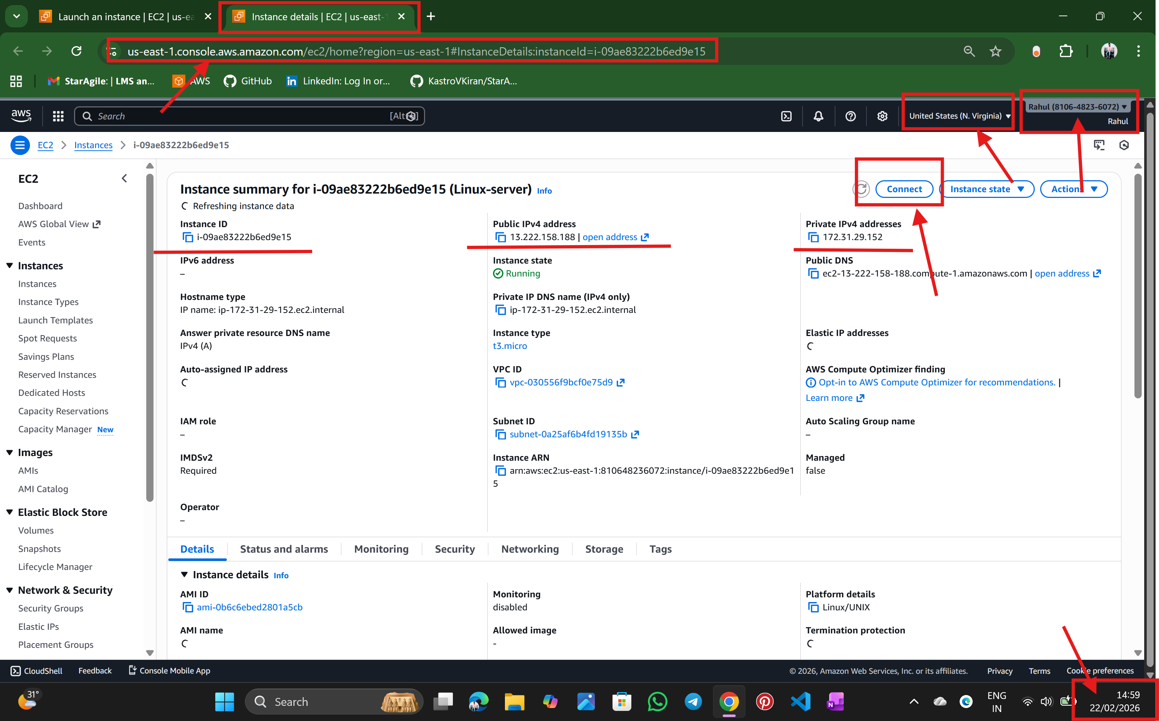

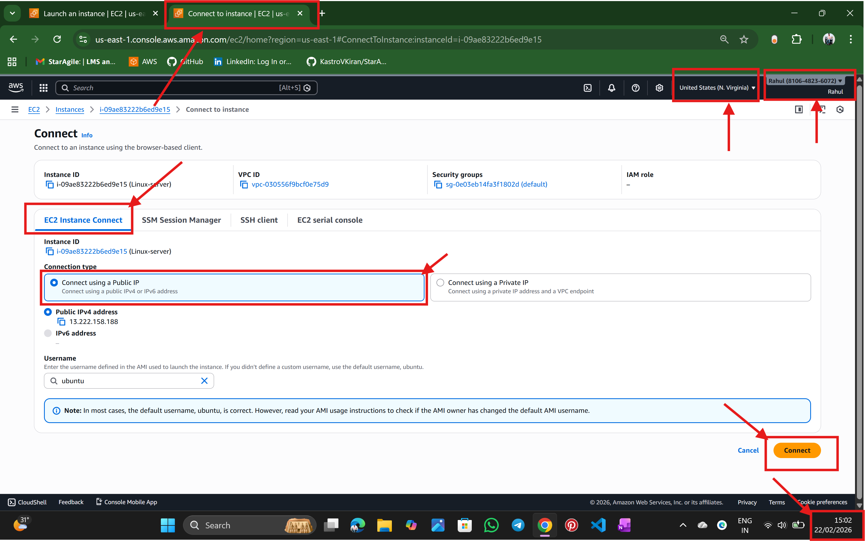

Step:3 Now the Ubuntu terminal is opened

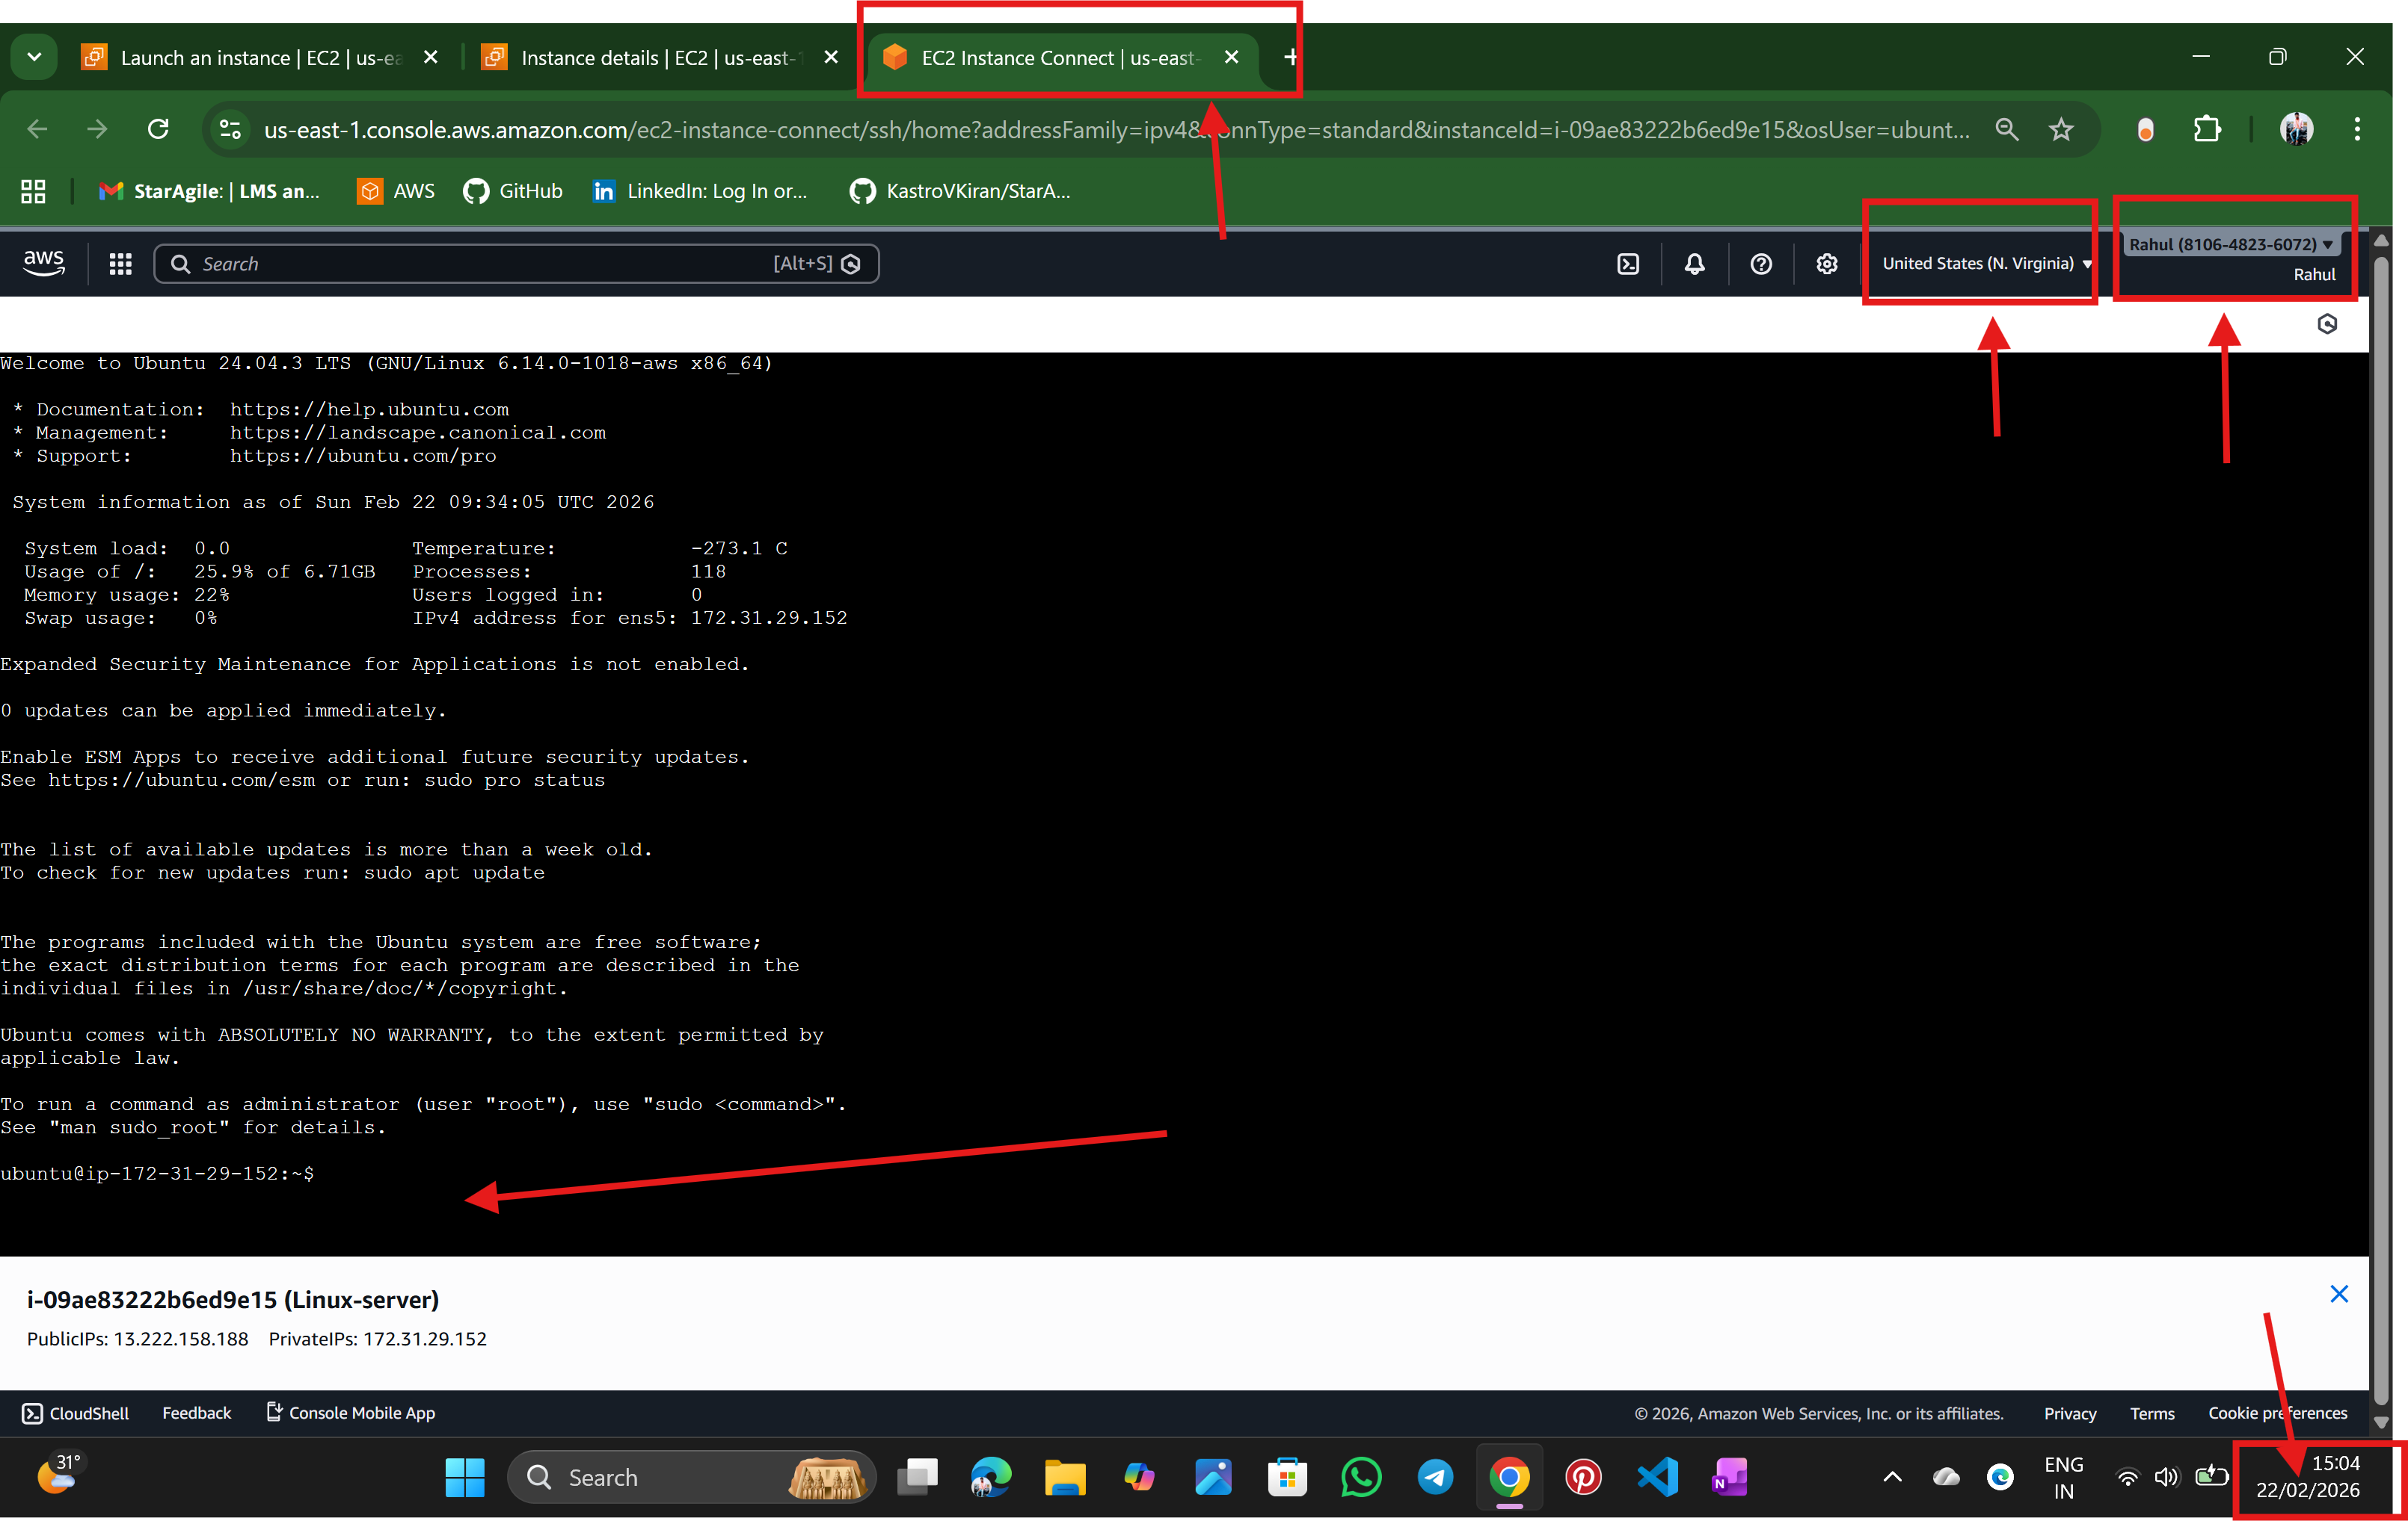

Step: 4 create a directory and create a file in it

🡪check the R/W/X permissions of the folder and file --- using -- ls -la command

🡪give only the R/W/X permission to only to owner and user group --- chmod 770

R = 4

W = 2

X = 1

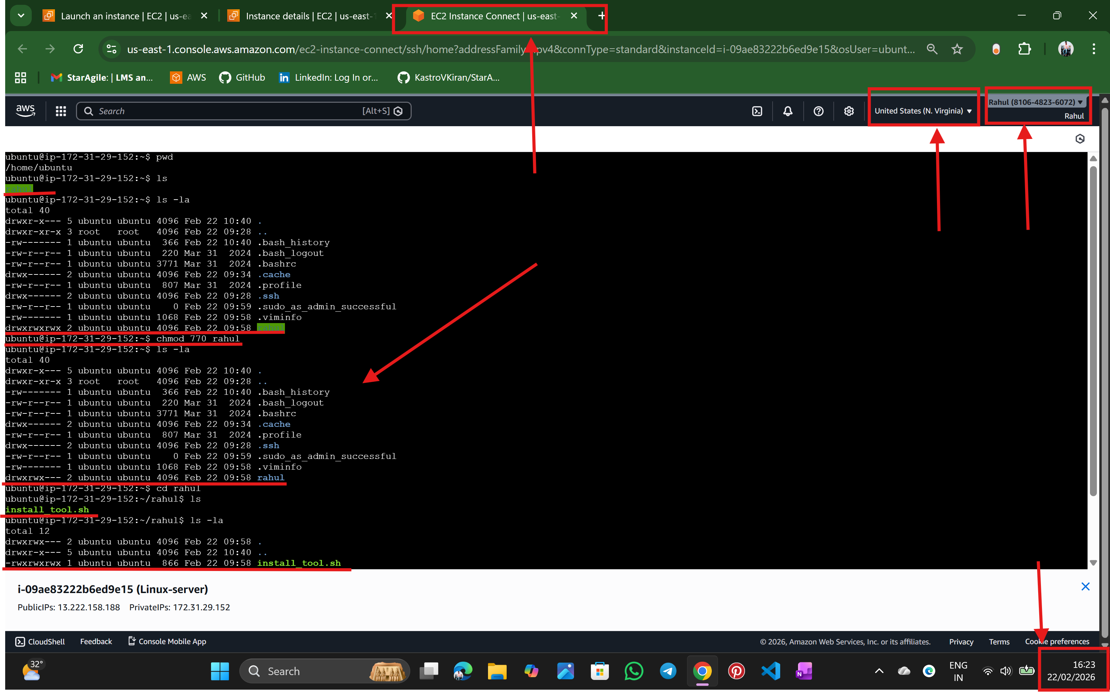

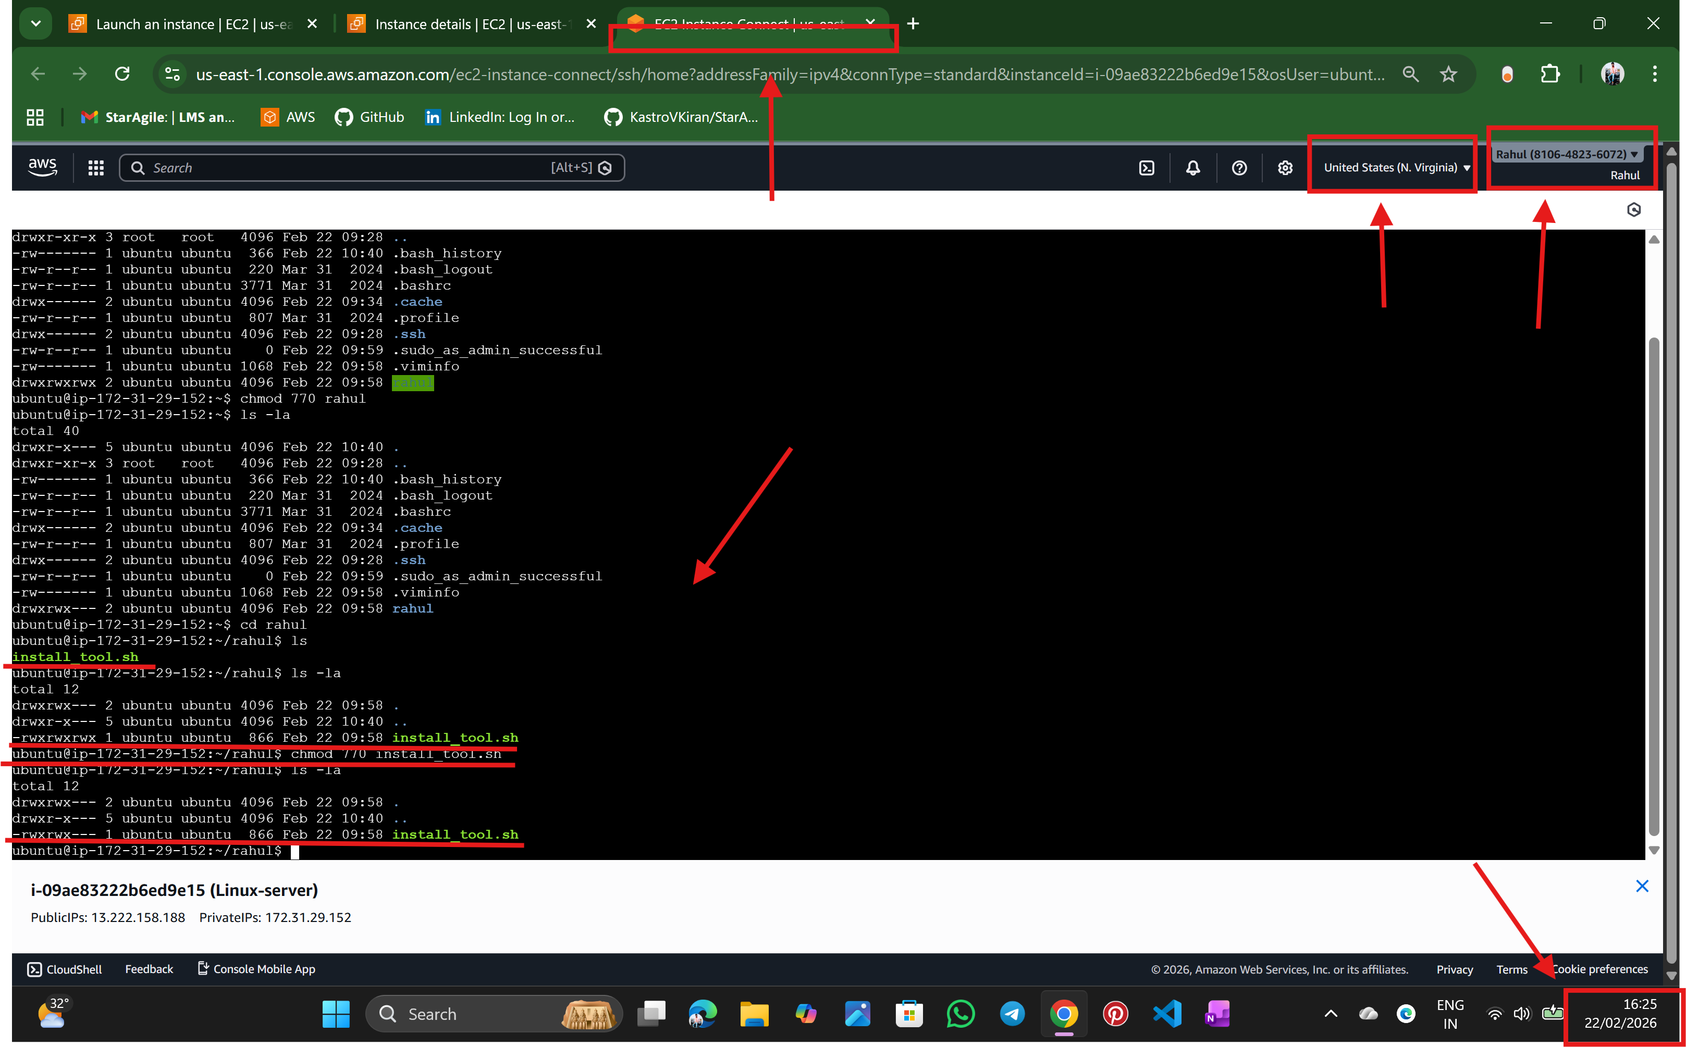

-----------------------------------------------THE END----------------------------------------------

🡪NALATHATI RAHUL